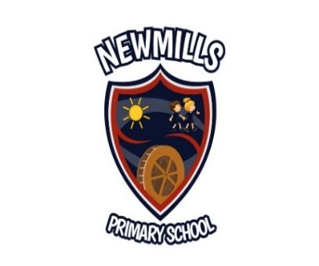

3rd July 2020
Dear Parent,
Our restart plan facilitates the return of all our pupils P1 – P7 on a full time basis with each class/ composite class as a ‘protective bubble’. We intend to bring all our pupils back to school during the week beginning 24th August but on a phased basis. Please see below for your child’s first day back.
P7 Monday 24th August 9.00am – 2.30pm
P2/P3 Wednesday 26th August 9.00am – 1.30pm
P4/P5/P6 Thursday 27th August 9.00am – 2.30pm
P1 pupils will come to school during week 24th August in small groups. P1 parents will be contacted individually regarding the details, but all P1 pupils will attend on Friday 28th August 9.00am – 1.30pm.
This will enable staff to familiarise the children with the routines and procedures of return and support them in their new surroundings.
Please remember that Monday 31st August is a Bank Holiday so school will be closed. All pupils will return on Tuesday 1st September, P1 – P3 9.00am – 1.30pm and P4 – P7 9.00am – 2.30pm.
We will no longer be able to provide early morning supervision or after school clubs at this time.
Pupils may arrive at school between the times of 8.30am and 8.55am. When they arrive they must go straight to their designated classroom and enter via the agreed entrance. Doors and gates will be locked at 9.00am.
Children should wear their school uniform and no tie will be required at this time. PE will take place outside and there will be no changing for PE at this time.
Boys – navy trousers, white shirt / white polo shirt, navy jumper, black shoes.
Girls – navy pinafore / skirt, white shirt / white polo shirt, navy cardigan / jumper, white socks, navy tights, black shoes.
P6 - P7 pupils should bring the following items to school on the first day; pencils, pens, rub out pens, scissors, sharpener, rubber, glue stick, colouring pencils, felt tips.
P4 - P5 pupils should bring the following items to school on the first day; pencils, scissors, sharpener, rubber, glue stick, colouring pencils, felt tips, highlighter pens.

P1, P2 and P3 should bring a labelled glue stick. All items will be placed in your child’s named tub/tray for their use only. All items will remain in school and pencil cases are not needed.
Lunch
For the week 24th August no school dinners will be available. Everyone will need to bring a packed lunch. A clearly named lunch box/bag and water bottle which can be cleaned every day will be required. We hope to be in a position to offer a hot meal from the 1st September.
Please bring a coat every day. We will be outside in all weathers during break, dinner time, PE and during outdoor learning. Break times and dinner times will be staggered allowing classes to remain in their ‘protective bubbles’.
This is to limit interaction with other classes and adults within school.
In order to maintain ‘protective bubbles’, parents/ carers are NOT permitted to enter the school building, except in pre-arranged circumstances. Parents / carers should not congregate at gates and ensure social distancing at all times.

Illness
Children who are ill must not be sent to school. If children become ill during the school day they will be moved to the Principal’s office and the parent /carer contacted. All parents must provide up to date contact numbers. These will be asked for in August.

Keeping in touch
Parents will be kept up to date through our school website / school app so please ensure you can access our website. There will also be specific information for each class through Home Learning prior to coming back to school. This can be accessed through the Parents tab on the school website.
If you have any questions about restarting school or any other queries I can be contacted via email at smillar500@c2ken.net.
On behalf of the governors and all the staff I wish you all a safe and enjoyable summer.

Yours sincerely,
Sandra Millar
Principal

