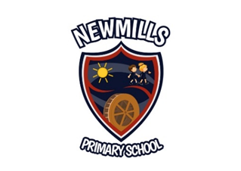
Newmills Primary School
96 Farlough Road
Newmills
Dungannon
BT71 4DX

Principal Mrs S Millar
Email smillar500@c2ken.net

Dear Parent,

The Northern Ireland Executive has announced that all schools are to extend their mid-term Halloween break by one week to reduce the transmission of COVID 19.

Therefore, school will close this Friday, 16th October for two weeks reopening Monday 2nd November. The School Development Day which had been planned for Monday 2nd of November will be rescheduled.

Education settings will be closed to all pupils during these two weeks including vulnerable children and children of key workers.

As this is an extension of the half-term break it is not intended to be used for remote learning, however, as a staff we feel that next week should be used as a revision week and as such some activities will be sent home with your child on Friday.

For those pupils who receive Free School Meals, direct payments will be made as was the case during the summer months.

Parent Teacher Interviews will take place this term via telephone and you will be contacted by your child’s teacher to arrange a suitable time.

We as a staff much prefer face to face teaching and we would ask that you continue to follow the guidance and to do whatever possible to limit the spread of the virus to enable our children to attend school to keep all in our community healthy.

If anyone needs to contact me outside school hours please email - smillar@c2ken.net

Finally, I would like to thank all our pupils, parents, staff and governors for their support since returning in August and commend them for the way they have adapted to all the changes that were necessary to keep us all safe. Have a restful and safe holiday.

Yours sincerely,
Mrs. Sandra Millar

